Analytical Report for displayed on the dashboards
The three dashboards—the Donation manager dashboard, the Regional manager dashboard, and the Relationship manager dashboard—that were taken from Power BI are interpreted in this report. The report presents the visualisations in a more straightforward and comprehensible manner. The dashboard is made up of many characteristics that form the foundation of the study, including donations, areas, states, cities, gender, and others. The study will include some insights and suggestions and will be based on the donations made by people from various cities, states, and regions.
Donation Manager Dashboard
The Donation Manager Dashboard is derived from the first dashboard.
- Regions: The West trails behind the Midwest and South-west in terms of contributions.
- Gender: 60% of donations are made by women, indicating a significant participation gap with men.
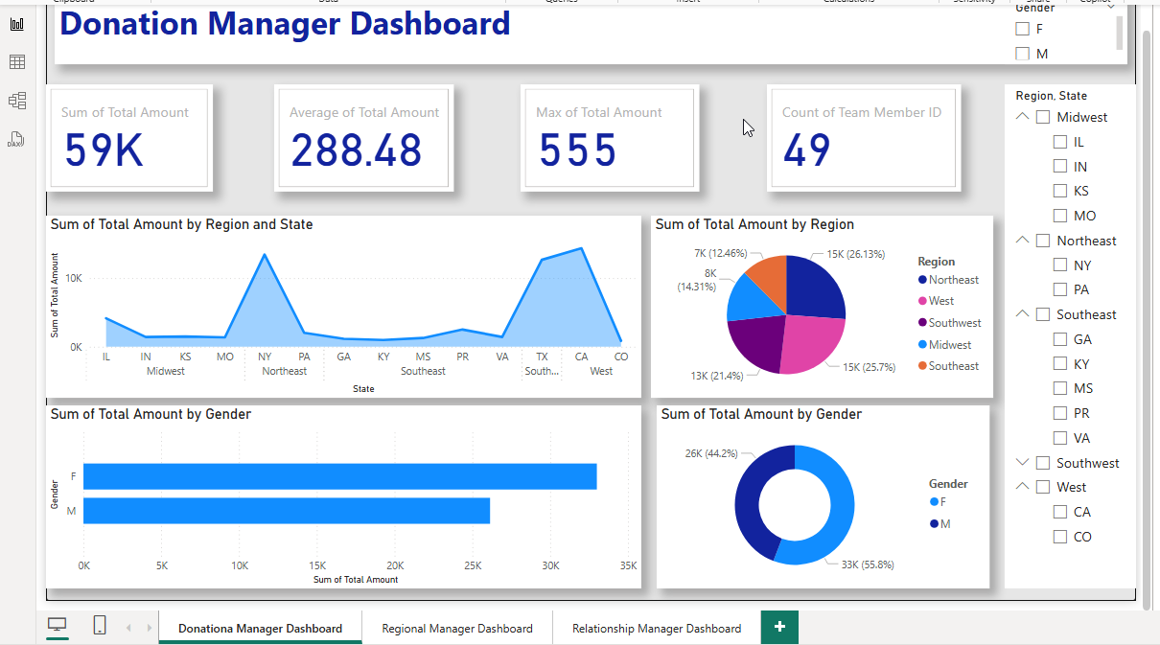
Recommandation
- Emphasis on High-Performing Regions: Research to increase donations in the West area; bolster efforts in the Midwest and South-west.
- Strengthen Gender Strategies: Develop focused initiatives to engage male contributors while crafting campaigns specifically for female donors.
Dashboard References
- Line and pie charts clearly show regional patterns.
- The gender gap in donations is shown with bar and doughnut charts..

Relationship Manager Dashboard
The Relationship Manager Dashboard offers important statistics on the distribution of genders in states and regions. Some states have notable gaps in representation, according to the statistics. This study examines the visualisations, derives useful information, and offers suggestions to resolve problems found.
Key Insight and Recommendation
- Gender Distribution by State and Region: The data points to incomplete entries and unequal gender representation.
It is suggested that in states with low representation, diversity initiatives be given priority and data collecting be improved.
- Regional Focus Areas Understanding: While useful, regional classifications lack specific measures.
It is suggested that gender-specific statistics be incorporated into regional diversity plans.
- Overall Perspective on Gender Representation: There is a gender gap, with one group accounting for 30% and the other for 20%.
It is advised that specific recruiting and retention initiatives be started for underrepresented genders and that labelling be made clearer.

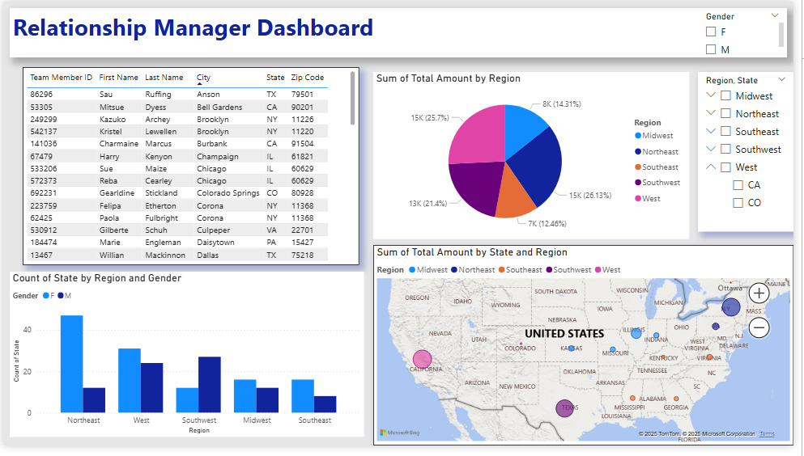

Relationship Manager Dashboard
The Relationship Manager Dashboard is derived from the first dashboard.
Key insight
- Gender: Women make up the majority of donors (20.24%), while men make up 29.76%.
- States & Regions: The Midwest and South-west make the most contributions, with Missouri and other Midwest states playing a particularly important role.
- Total Donation: An overall success of $59,139 is demonstrated.
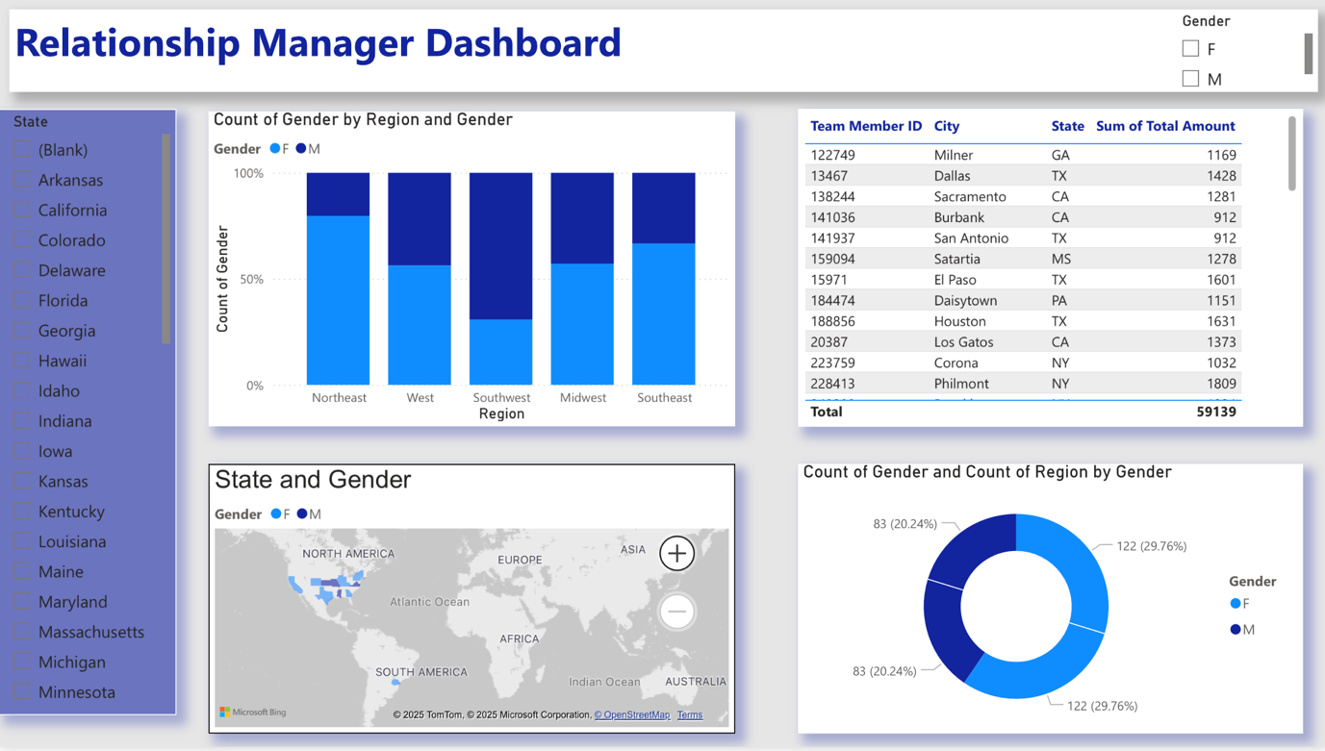

Recommendations:
- Encourage Female Donor efforts: Since women make up the majority of donors, focus on tailored efforts to increase participation.
- Scale Midwest & South-west Efforts: Make use of these top areas for effective fundraising tactics. Examine possible obstacles in underperforming areas, such as the West.
- Localised Targeting: Given their significance, states like Missouri may profit from more outreach.

